**“LibertyLink: PDL Management System”**

**Leader:**

**Dela Cruz, Justin Norie B.**

**Members:**

**Apolinar, Julien**

**Baja, Brando**

**Baloran, Leonardo**

**Datuin, Khiejay**

**Permejo, Jaypee**

**Sombilon, Johnpaul**

**Section**

**BSIT – 2B**

**Chapter 1**

**Introduction**

In the digital age, technology has transformed correctional facilities by improving operations, transparency, and outcomes for incarcerated individuals. Digital tools streamline processes, optimize resource allocation, enhance security, and support rehabilitation programs within correctional systems. Republic Act No. 10575, the "Bureau of Corrections Act of 2013," is a key law that sets policies and standards for correctional services in the Philippines. It reflects the State's commitment to promoting PDL (Person Deprived of Liberty) welfare, focusing on reformation, social reintegration, and international standards compliance. The development of a comprehensive PDL Management System aligns with RA 10575's objectives, fostering a rehabilitative environment and ensuring humane treatment of PDLs.

The PDL Management System is a new way of managing correctional facilities, using technology to improve efficiency and overcome challenges. This system includes digital tools for handling PDL records, scheduling visitor visits, and monitoring of facilities. By centralizing and automating these important tasks, the system improves transparency, accountability, and the effectiveness of rehabilitation efforts in correctional facilities. This document explores the features and importance of the PDL Management System in supporting the principles of RA 10575 and promoting the goals of reforming and reintegrating Persons Deprived of Liberty back into society.

**REPUBLIC ACT NO. 10575, also known as THE BUREAU OF CORRECTIONS ACT OF 2013 Section 2. Declaration of Policy. It is the policy of the State to promote the general welfare and safeguard the basic rights of every prisoner incarcerated in our national penitentiary by promoting and ensuring their reformation and social reintegration, creating an environment conducive to rehabilitation and**

**compliant with the United Nations Standard Minimum Rules for Treatment of Prisoners (UNSMRTP). It also recognizes the responsibility of the State to strengthen government capability aimed towards the institutionalization of highly efficient and competent correctional services.**

**Project Context**

Effective management of prisoner information and visitation schedules is critical for correctional facilities. Current systems often face challenges with inefficiency and inaccuracies, which can compromise security and operational effectiveness. The PDL Management System is designed to solve these problems by automating the recording and management of detailed prisoner data and scheduling visits more efficiently. This project will introduce a digital solution to streamline these processes, ensuring that records are accurate and up-to-date, enhancing security, and improving overall facility operations. The goal is to modernize the administration of correctional facilities, thereby supporting safer and more efficient management practices.

The PDL Management System is a tool that helps efficiently record and manage pdl information. This system is important because it simplifies the tracking of pdl details, including their personal information and visitation schedules. It aids in safer and more organized operations within detention facilities, facilitating faster and smoother visitation processes.

To develop this system, the utilization of tools like Microsoft Visual Studio, Visual Studio Code, Figma, and XAMPP enables us to create a robust and user-friendly platform that supports modern correctional facility management practices.

By replacing manual workflows with digital solutions, we aim to improve the overall efficiency and effectiveness of correctional facilities, ultimately contributing to the reformation and social reintegration goals outlined in Republic Act No. 10575.

**Purpose and Description**

The main purpose of developing the PDL Management System is to address the challenges and inefficiencies associated with manual correctional management processes. By automating key workflows such as inmate record updates, visitor scheduling, and reporting, the system aims to improve data accuracy, compliance with regulatory standards, and operational efficiency.

The PDL Management System offers significant benefits to various stakeholders within correctional facilities. Administrators benefit from streamlined processes in PDL record management, visitation scheduling, and reporting, reducing manual effort, minimizing errors, and ensuring accurate data management. Users, particularly visitors scheduling visits to Persons Deprived of Liberty (PDLs), benefit from streamlined visitation processes and enhanced transparency. The system provides a user-friendly interface for scheduling appointments, receiving automated confirmations, and accessing visitation guidelines, enhancing the overall visitor experience and ensuring efficient visitation management. Correctional facilities benefit from optimized resource allocation and improved operational transparency through the PDL Management System. It enables efficient PDL record management, visitation scheduling, and facility oversight, ultimately enhancing correctional facility operations and compliance with legal and regulatory requirements.

**Objectives**

The project developers intend to develop a PDL (Persons Deprived of Liberty) Management System, focusing on automating inmate record management and optimizing visitation scheduling within correctional facilities.

Specifically, the goal of this project is to:

1. Develop a system to automate PDL record management, encompassing personal details, legal statuses, and cell block information for accuracy and efficiency.
2. Implement an intuitive interface for visitors to schedule appointments with PDLs, ensuring ease of use and seamless visitation processes.
3. Create a dynamic dashboard displaying key metrics of the correctional facility, including active PDLs, released PDLs, total visits, and comprehensive cell block information.
4. Enable administrators to manage and configure cell blocks within the facility, allowing precise modification of block numbers, capacities, and gender units.
5. Implement features for tracking visitor interactions, maintaining visitation histories, and managing visitor records to facilitate efficient visitation processes.

**Scope and Delimitation**

The PDL (Persons Deprived of Liberty) Management System is developed to offer correctional facilities a comprehensive solution for inmate record management and visitation scheduling. This system aims to streamline inmate record processes by automating the creation, updating, and retrieval of PDL records, encompassing personal information, legal status, and behavioral assessments. Additionally, the system facilitates efficient visitation scheduling for PDLs, allowing visitors to access available dates and times, make appointments, and receive confirmations. With a user-friendly interface designed for both correctional facility administrators and visitors, the system provides accessibility and ease of use. Furthermore, the system acts as a centralized information hub, ensuring transparency, accuracy, and compliance with regulatory standards in correctional facility operations.

However, certain limitations and constraints are inherent in the design and implementation of the PDL Management System. The system's performance may be influenced by hardware dependencies, including specific memory and processing requirements. Regulatory compliance is essential, requiring adherence to legal and regulatory policies governing data privacy, security, and information handling practices within correctional facilities. Language accessibility may pose limitations for users preferring alternative linguistic interfaces despite efforts to ensure a user-friendly experience.

**Technical Background**

The technical implementation of the PDL (Persons Deprived of Liberty) Management System leverages a suite of essential applications and programming languages to ensure robust functionality and user-friendly interfaces. Microsoft Visual Studio 2022 serves as the primary development environment for creating the graphical user interface (GUI) and administrative functionalities tailored to correctional facility administrators. This platform enables the design and implementation of intuitive tools for managing inmate records, visitation scheduling, and overall facility operations. Visual Studio Code complements the system by facilitating the development of the web-based component dedicated to scheduling appointment visits. Through HTML, CSS, and JavaScript coding, Visual Studio Code enables the creation of dynamic web pages, optimizing user interaction and experience.

For design and prototyping, Figma is utilized to visualize and iterate the system's GUI layout and website design, ensuring a cohesive and user-friendly interface. Additionally, database integration is facilitated by XAMPP, which establishes secure connections to MySQL databases. XAMPP enables efficient creation, storage, and updating of essential information, including PDL records, visitation schedules, and administrative data. The combination of Visual Basic (VB.NET) and HTML/CSS/JavaScript programming languages empowers the development team to implement core functionalities, structure, and graphical elements for both the administrative GUI and the web-based appointment scheduling interface.

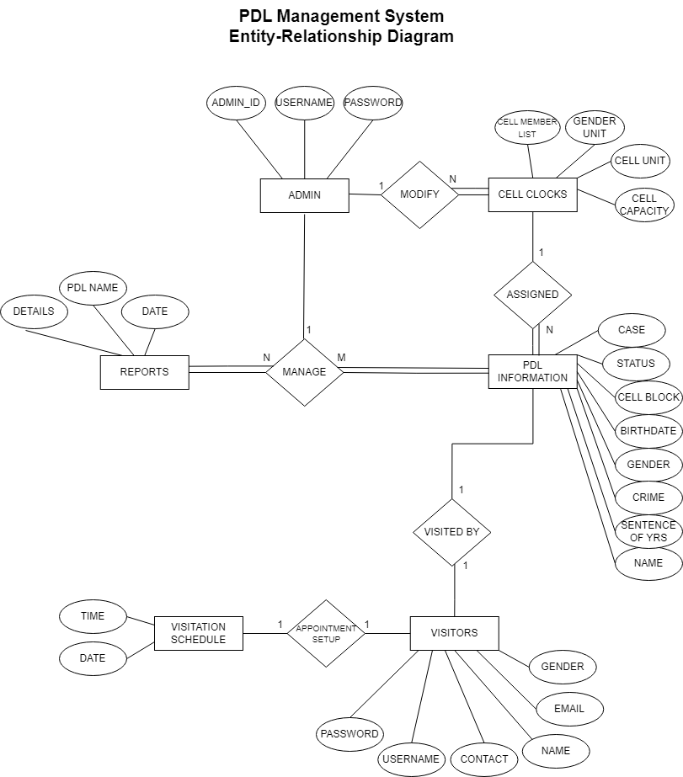

**Figure 1.1 Entity-Relationship Diagram**

In Figure 1.1, the Entity-Relationship Diagram (ERD) illustrates the connections among various entities in developed system. The LibertyLink: PDL Management System system comprises six (6) major entities: Admin, Cell Clocks, PDL Information, Visitors, Visitation Schedule, and Reports, all linked through the Manage relationship. The Admin entity, containing ADMIN_ID, USERNAME, and PASSWORD attributes, is crucial for overall system management for modifying cell clocks and managing reports and PDL information. The Cell Clocks entity includes CELL_MEMBER_LIST, GENDER_UNIT, CELL_UNIT, and CELL_CAPACITY attributes, which are modified by the Admin entity to track and manage inmate information within different cell units.

The PDL Information entity includes attributes such as NAME, SENTENCE_OF_YRS, CRIME, GENDER, BIRTHDATE, CELL_BLOCK, STATUS, CASE, CELL UNIT, and VISITED_BY, providing detailed information about each Person Deprived of Liberty (PDL). The Visitors entity, with NAME, CONTACT, USERNAME, PASSWORD, and EMAIL attributes, facilitates setting up appointments through the Visitation Schedule entity, which manages visit scheduling with DATE and TIME attributes. The Reports entity, managed by the Admin, contains PDL_NAME, DETAILS, and DATE attributes, documenting all activities and changes related to inmates. The Manage relationship connects the Admin entity with the Reports and PDL Information entities, highlighting the Admin's control over these critical components.

The system incorporates Create, Read, Update, and Delete (CRUD) functionalities to manage the information effectively. These CRUD operations enable the Admin to create new entries, read existing data, update records, and delete outdated or incorrect information, ensuring the database remains accurate and up-to-date. This ERD provides a structured overview of the LibertyLink: PDL Management System, emphasizing the central role of the Admin in modifying and managing system elements, the detailed data held within the PDL Information entity, and the facilitation of visitor scheduling through interconnected entities.

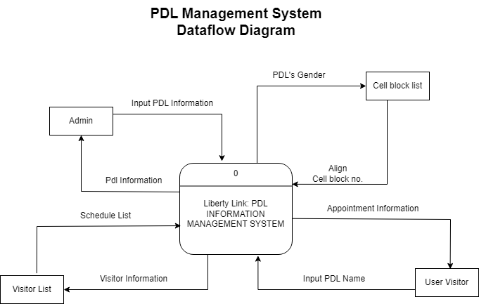

**Figure 1.2 Data Flow Diagram**

In Figure 1.2, the Level 0 data flow diagram, provides an overview of the LibertyLink: PDL (Person Deprived of Liberty) Management System and its interactions with external entities. The diagram features four (4) primary entities: Admin, Cell Block List, Visitor List, and User Visitor. The Admin entity inputs PDL information, while the Cell Block List supplies cell block details for aligning PDL’s gender with the appropriate cell block number. The Visitor List receives visitor information and schedules from the system, and the User Visitor inputs the PDL name for appointment information and identity verification.

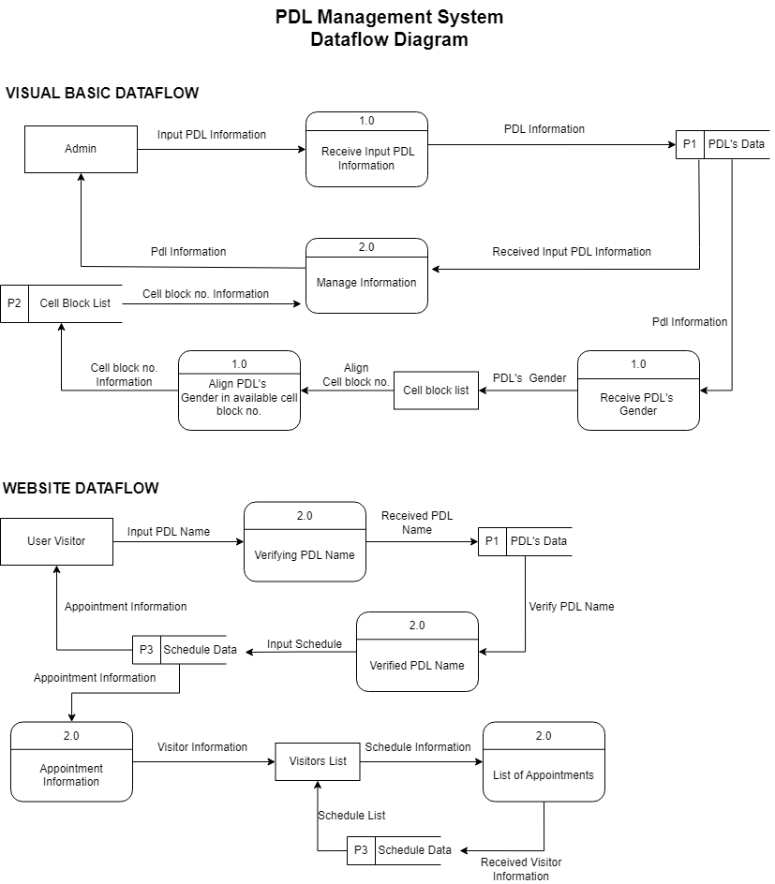

**Figure 1.3 Data Flow Diagram**

In Figure 1.3, the Visual Basic Data Flow Diagram (Level 1) breaks down the PDL Management System into detailed processes. It includes processes for receiving input PDL information from the Admin, managing and aligning this information with the cell block list, and aligning the PDL’s gender with the available cell block number. The Website Data Flow Diagram (Level 1) outlines the web-based interactions. It includes processes for verifying the PDL name inputted by the User Visitor, allowing the user to input appointment schedules, and managing visitor information based on these schedules. This ensures smooth data flow between the entities and the system for accurate and efficient PDL and visitor management.

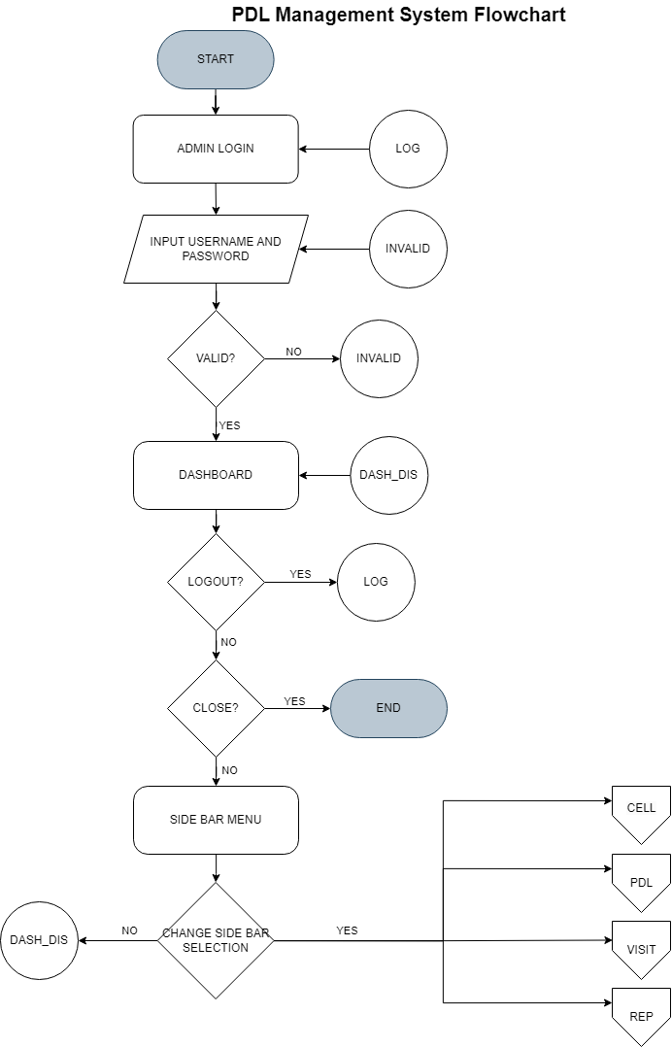

**Figure 2.1 Desktop Application**

**Flowchart Page I**

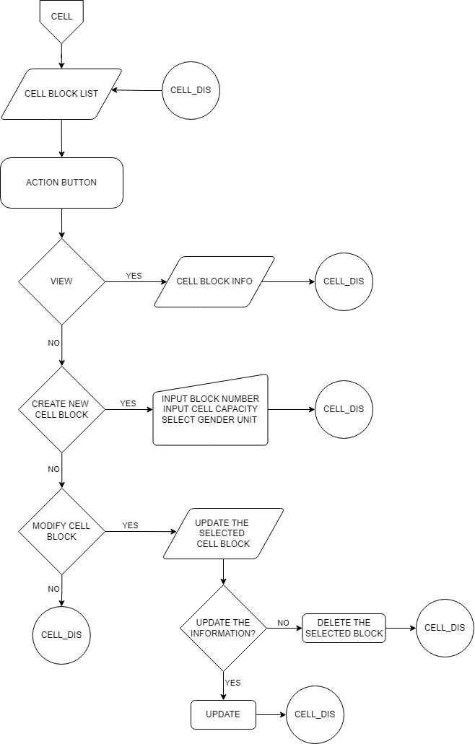

**Figure 2.2 Desktop Application**

**Flowchart Page 2**

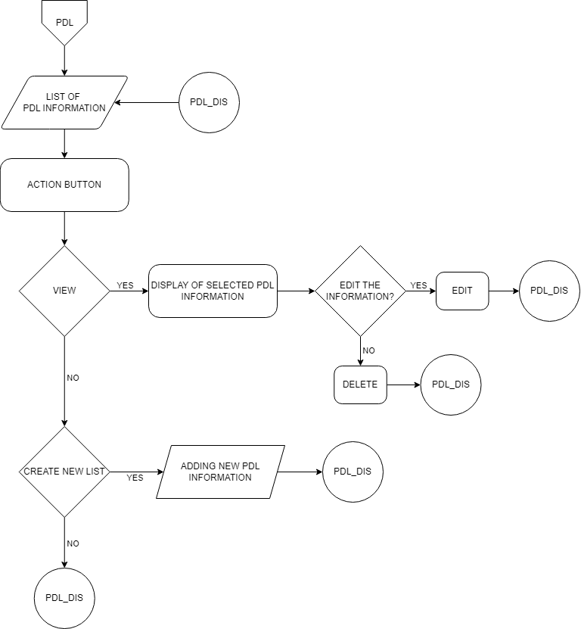

**Figure 2.3 Desktop Application**

**Flowchart Page 3**

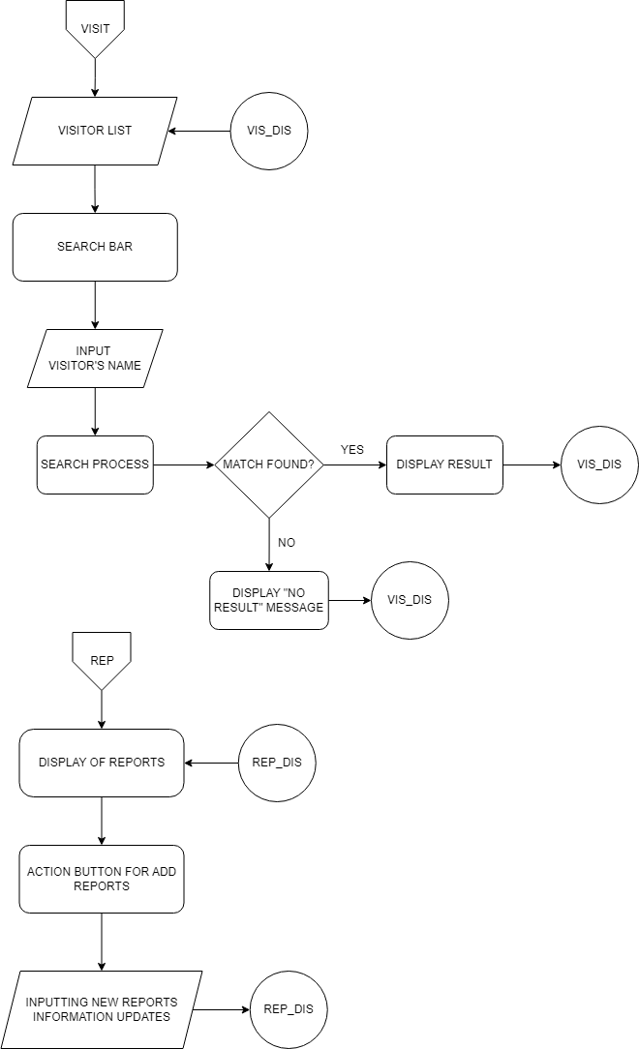

**Figure 2.4 Desktop Application**

**Flowchart Page 4**



**Figure 2.5 Website Application**

**Flowchart Page 5**

In The flowchart of the PDL Management System provides a structured description of the system's functionalities and workflows designed for correctional facility administrators. At its core, the system begins with the main dashboard, acting as a central hub where administrators can access vital metrics and features, including total active PDLs, released PDLs, scheduled visits for the day, and the count of facility cell blocks. Within this framework, administrators can seamlessly navigate to specific modules designed to optimize correctional management. The PDL Record Management module streamlines the creation, update, and retrieval of detailed PDL records, encompassing personal data, legal statuses, and cell block assignments, ensuring data accuracy and regulatory compliance.

The Visitor List module plays a crucial role in managing and organizing visitor appointments, allowing to view visitors schedule, and confirmations for each appointment. This intuitive interface improves the visitor's experience and facilitates efficient coordination for visitation. The Cell Block Management module enables administrators to efficiently oversee and adjust cell block configurations, including block number assignments, cell capacities, and gender unit allocations, optimizing facility resource utilization.

For users, particularly visitors seeking to schedule appointments with their related PDLs, the PDL Management System offers an intuitive and accessible interface. The system includes a dedicated website component designed for appointment scheduling. Visitors can access the website to view available visitation dates and times, schedule appointments with PDLs, and receive confirmation display. The website's user-friendly design simplifies the appointment scheduling process, ensuring a smooth and efficient experience for visitors. Through this system, visitors can easily visitation processes in accordance with facility regulations and guidelines.

**Chapter 2**

**REVIEW OF RELATED LITERATURE, STUDIES, AND SYSTEMS**

**Review of Related Literature**

In this chapter, various local and foreign literature, studies, and systems were reviewed to gain an understanding of existing research and other academic works relevant to the area of study, thereby presenting a broader knowledge to the academic community and simultaneously helping to intensify our knowledge in the project system.

According to Willsey (2023), the current reliance on manual, paper-based systems is prone to human error and can result in serious mistakes, such as the release of incorrect PDL. Implementing an automated prison management system can address these challenges by streamlining administrative tasks, reducing human error, and providing real-time monitoring and accurate record-keeping. This can improve overall efficiency, enhance security, and better manage prison populations and staffing. Deploying a prison management solution can significantly improve the current state of prisons by automating processes and offering a comprehensive view of PDL information. Such systems help reduce overcrowding by enabling better planning and management of accommodations, improving staff-to-PDL ratios, and enhancing overall safety and security. With these solutions can aid in reducing recidivism by providing accurate tracking and monitoring of offenders, ensuring more informed decision-making and compliance with regulatory requirements.

This system is related to our system because just like this system ours also provides real-time monitoring and accurate record-keeping of PDL to improve efficiency and security to manage the prison better. And also we build this system to reduce human error that can result in serious mistake.

- Khiejay Datuin

According to Aspiras (2020) This study involves the development of an Integrated Jail Management System covering the seven Major penal institutions in the Philippines, which are Being administered by the Bureau of Corrections (BuCor). It includes the entire process of storing, Retrieving and maintaining data of the inmates that Includes their personal profile, case information, jail Location history and the status of their cases. It focuses On the accurate computation of the expiration of the Minimum and maximum sentences of the inmates to Determine the prompt monitoring of their releases. Although this study is limited to the major penal Institutions for pilot testing, future studies may consider The interconnectivity of the pilot phase to the other Agencies involved in the administration of justice such as The Bureau of Jail Management and Penology which Administers the local jails. The Bureau of Corrections is an agency under The Department of Justice, which acts as the institutional Base of rehabilitating prisoners. It manages and operates All the major prison institutions in the Philippines. Aside From the New Bilibid Prison (NBP) in Muntinlupa City. This system of ours is related to our system because it manages personal information, case information and records of inmates and these system we have the database of prisoner's and administrator can have and update all the details.

- Leonardo Baloran

According to Jillian J Turanovic and Melinda Tasca (2019), prison visitation plays a crucial role in pdl social connections and behavior. However, not all visits are positive, and little is known about why. The study focused on inmates’ experiences with visitation, analyzing data from 228 pdl’s. Results showed varied feelings during visits, influenced by factors like visit frequency and pdl’s pre-prison behaviors. This highlights the need for conflict resolution resources during visits. Family-centric interventions could improve visitation effectiveness, especially when considering the diversity of inmate experiences. Improved information management systems could aid in tracking visitation patterns and addressing pdl needs effectively. This system is related to our system just like the visitation experience and the tracking visitation where those who visit the PDLs are tracked and the security of the information of the PDL.It helps monitor who interacts with the individual and can aid in ensuring their safety, preventing unauthorized communication or smuggling of contraband, and maintaining order within the facility. This tracking typically involves registering visitors, verifying their identities, and sometimes conducting searches or screenings before allowing access. It’s an essential part of the security protocol in such environments.

- Julien Apolinar

According to Ahmed Ataullah (2019) entitled "A Framework for Records Management in Relational Database Systems", Storage of records has always been a fundamental objective of information systems. However in the past decade managing sensitive information throughout its lifecycle, from creation to destruction (or archival), has become of significant importance. The increasing awareness of the impact of technology on privacy has added momentum to the need to have better enforcement of records retention policies. Organizations today not only have to comply with regulations, but also have to maintain a balance between operational record keeping requirements, minimizing liability of storing private information, and customer privacy preferences. In related with the study above, this work will not attempt to define the term "record" in the broad. context. Instead the term will be treated in all its generality and then applied to the world of relational databases. Without attempting to differentiate terms such as data, knowledge, information and record, it is recommended that the reader maintain a simple but consistent definition of a record throughout this research.

- Jaypee Permejo

According to ND Oye and Ibrahim Inuwa in the West African Journal of Industrial and Academic Research (2019), advancements in technology have led to the automation of system processes across various fields. Their study examined the manual processing of prisoners’ information in Yola Prison, Adamawa State, and proposed an “Automated Prison Information System.” This system aims to provide efficient computation, reliable data storage, easy access, and retrieval of information for authorized users, and high security for prisoners’ records. Features include prisoner registration at intake and discharge, and searching and viewing reports for current and former inmates. Compared to manual systems, this automated approach is more secure, flexible, user-friendly, and reduces errors, enhancing inmate information management and continuous tracking of offenders.

In related the system focuses on collecting and managing information for pdl. By automating PDL information management, it aims to streamline data collection, storage, and retrieval processes. This system will provide accurate and up-to-date information on inmate profiles, case details, operational efficiency, and security within correctional facilities.

- Johnpaul Sombilon

According to Mbatha, Luthuli, and Masenya's study in the Journal of the South African Society of Archivists (2020), information systems are increasingly used in African correctional facilities to manage records and improve operations. While these systems have streamlined information flow in some prisons, challenges persist, particularly in countries like South Africa, where traditional record-keeping methods prevail due to financial constraints and limited government support. The study emphasizes the need for collaborative strategies and benchmarking initiatives to enhance the effectiveness of information systems and record management in correctional facilities.

This aligns with the purpose of my system, which focuses on collecting and managing information for persons deprived of liberty (PDL). By implementing an advanced information management system, my goal is to address the issues of inefficient record-keeping and enhance the overall management of inmate data. This system will facilitate accurate and timely access to inmate records, including personal profiles, case information, and release eligibility, thereby improving decision-making processes and operational efficiency within the correctional facilities.

- Brando Baja

According to Wahome (2019), the doctoral dissertation titled "Jail Management Information System: A Case Study of Kamiti Maximum Security Prison" was conducted at Ndejje University. The study focused on developing a jail management information system specifically tailored for Kamiti Maximum Security Prison. The research aimed to address challenges in information management within the prison environment. Data collection methods included surveys and interviews with prison staff and visitors. Findings underscored the need for a computer-based solution to enhance data security, accessibility, and efficiency. The dissertation recommended the adoption of the developed system to improve information management practices within the facility.

This research is related to the PDL information management system as it highlights the importance to improve data security, accessibility, and efficiency in correctional facilities. By adopting similar computer-based solutions, such as the one proposed in Wahome's dissertation, correctional facilities can enhance their overall operational effectiveness and security in managing PDL information.

- Justine Norie Dela Cruz

**Synthesis of the Review**

The Comprehensive PDL Management System encompasses the pivotal role of automated systems in handling information related to persons deprived of liberty (PDL). Willsey's (2023) research underscores the efficiency brought by automated systems in streamlining administrative tasks, minimizing errors, and providing real-time monitoring capabilities. This ensures accurate data regarding inmate profiles, case details, and release monitoring, thereby facilitating informed decision-making and operational effectiveness. Similarly, Aspiras (2020) emphasizes the significance of comprehensive data management in major penal institutions, highlighting the importance of maintaining precise records to enable efficient PDL management and monitoring. Leveraging technology, these systems provide reliable storage of PDL records, ensuring ease of access and minimizing the risk of errors associated with manual processes. Moreover, Ataullah (2019) stresses the importance of robust records management practices in relational database systems, particularly concerning the handling of sensitive PDL information to ensure regulatory compliance and enhance data security. Additionally, Mbatha, Luthuli, and Masenya (2020) highlight the growing adoption of information systems in African correctional facilities to streamline record management processes, contributing to enhanced operational efficiency and decision-making capabilities. Effective management of prison visitation, as discussed by Turanovic and Tasca (2019), is also crucial for facilitating social connections and supporting the main and sub-main functions of the PDL management system. Improved information systems facilitate the tracking of visitation patterns and provide necessary resources for conflict resolution, thereby enhancing the effectiveness of visitation programs and overall PDL management and monitoring. Lastly, the deployment of the system using Frameworks-Dependent Deployment with Microsoft Visual Studio ensures its efficient implementation and functionality.

The study on PDL Information Management Systems reveals their crucial role in modern prison administration. Recent research highlights how these systems streamline administrative tasks, minimize errors, and provide real-time monitoring capabilities, ensuring accurate inmate data. Leveraging technology, they offer reliable storage of PDL records, enhancing operational efficiency and decision-making. Improved systems also facilitate effective management of prison visitation, crucial for social connections and PDL monitoring. Deployment using advanced frameworks like Microsoft Visual Studio ensures efficient implementation and functionality.

**Chapter 3**

**EVALUATION, DESIGN, AND FRAMEWORK**

This chapter deals with the presentation of the discussion of expected and justification, operational and conceptual framework used, the software, hardware, client requirements as well as the definition of terms.

**Discussion of the Expected Output and Justification**

The expected output for the "LibertyLink: PDL Management System" is a comprehensive, efficient, and user-friendly platform designed to manage various aspects of PDL (Person Deprived of Liberty) information, visitation schedules, cell block assignments, and creating a reports. The system aims to streamline the complex process of managing PDL data, making it accessible and manageable for administrators through a desktop application and enabling user visitors to schedule and verify visits via a web interface. The primary features of LibertyLink include robust information management, visitation scheduling, and detailed reporting functionalities.

The information management module ensures that administrators can easily input, update, and manage comprehensive PDL information, including personal details, cell assignments, and status updates. This module simplifies the task of keeping accurate and up-to-date records, reducing the likelihood of errors and ensuring data integrity. Visitation scheduling feature is designed to facilitate the process of booking and managing visitations. Visitors can input the PDL name, verify their identity, and schedule visits through a straightforward web interface. This system provides appointment confirmations and reminders, reducing confusion and ensuring that all visits are well-coordinated and documented. The feature aims to improve the experience for both the PDLs and their visitors by making the visitation process more transparent and organized.

The reporting module in LibertyLink is another critical component, allowing administrators to generate detailed reports on various aspects of PDL management, such as visitation records, cell block assignments, and overall population statistics. These reports provide valuable insights for decision-making and ensure compliance with regulatory requirements.

The development of the LibertyLink: PDL Management System is necessary given the increasing need for efficient and secure management of PDLs within correctional facilities. The system addresses several key challenges, including the need for accurate data management, streamlined visitation processes, and comprehensive reporting capabilities. By integrating these features into a single platform, LibertyLink enhances the efficiency, security, and overall user satisfaction within the PDL management context.

In terms of security, LibertyLink is designed to maintain the confidentiality and integrity of sensitive PDL and visitor information. User accounts are secured with strong authentication mechanisms, and all personal data is encrypted to protect against unauthorized access. This focus on security ensures that the system complies with data protection regulations and safeguards the privacy of all users. The project developers have conducted thorough research on data management, user interface design, and security protocols to ensure that LibertyLink is a robust and user-friendly system. By combining these technologies and design principles, LibertyLink is set to significantly improve the management of PDL information and visitation schedules, providing a seamless experience for administrators and visitors alike. The development of LibertyLink is justified by the clear need for a system that can handle the complexities of PDL management efficiently. By addressing key challenges and integrating advanced features, LibertyLink aims to revolutionize the way PDL information and visitations are managed, ultimately enhancing the operational efficiency and security of correctional facilities.

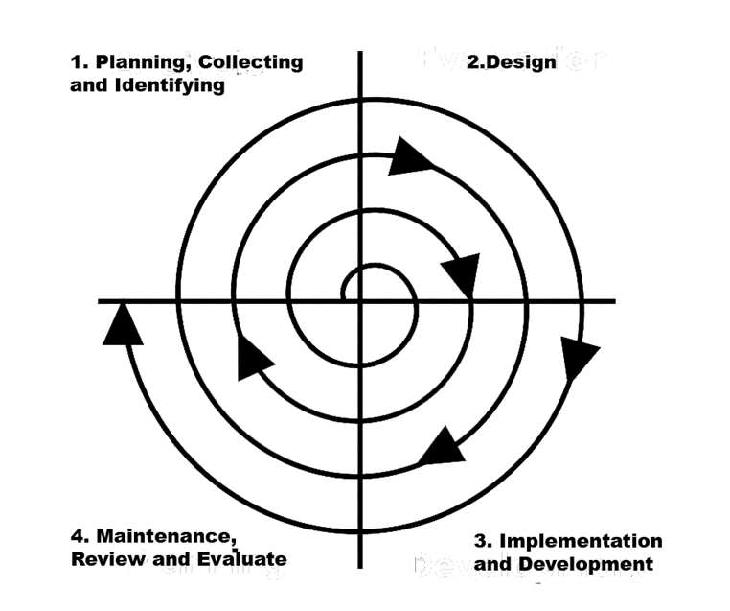**Operational Framework**

**Figure 1**

**An Operational Framework illustrating the development of PDL Management System, LibertyLink, using Spiral Model**

The project developers implement the spiral model for the development and maintenance of the LibertyLink: PDL Management System. This iterative process allows the team to revisit different stages of development whenever an issue arises, ensuring continuous refinement and improvement of the system. This circular process will continue until the developers are confident that LibertyLink is fully operational, robust, and free from bugs.

In the first phase, the project developers collect all the necessary information for the creation of the PDL Management System, LibertyLink. This phase involves laying out a comprehensive plan detailing the development process from start to finish. The plan includes the collection of requirements for LibertyLink, incorporating all essential features, functionalities, and performance criteria. This step is crucial to ensure that the system aligns with the needs of correctional facility administrators and user visitors. During this phase, the developers identify stakeholders and gather their requirements, define the scope and objectives of the system, establish timelines, resources, and budget estimates.

Based on the requirements collected in the planning phase, the project developers proceed to the collecting and identifying phase. This phase focuses on detailing the functional and non-functional requirements of the system. It involves creating detailed specifications and identifying the necessary technologies and tools for the development. Key activities include elaborating detailed functional requirements for PDL information management, visitation scheduling, and reports, identifying system constraints and performance requirements, selecting suitable technologies and tools for development, and technical evaluations.

In the third phase, the project developers begin the design and implementation of LibertyLink as per the detailed specifications. This phase involves creating the system functionalities, designing the user interface and database. The developers then proceed with coding, integrating, and configuring all the previously defined functionalities. In-depth testing is conducted to identify and fix any bugs or issues. This phase includes designing the system functionalities and database schema, developing a user-friendly graphical user interface (GUI), coding and implementing the core functionalities such as PDL information management, cell block assignments, and visitation scheduling, integrating security measures to protect sensitive data, integration of website, and system testing to ensure functionality and robustness.

In the fourth and final phase, the project developers move into the maintenance stage of LibertyLink. This phase involves thorough testing of the system to identify any possible errors or bugs that might have been overlooked in previous phases. Any issues identified are promptly fixed until the developers are confident that the system is fully functional and meets the high standards set. Ongoing maintenance activities are conducted to ensure the system remains reliable and effective. This phase includes performing comprehensive system testing to ensure stability and performance, monitoring the system for any issues or bugs in real-world usage, providing regular updates and patches to improve functionality and security, gathering user feedback and making continuous improvements, and conducting regular reviews and evaluations to ensure the system meets the evolving needs of users.

**Conceptual Framework**

PROCESS

INPUT

OUTPUT

**DESKTOP DEVELOPMENT:**

Visual Studio Code 2022 (VB.NET)

XAMPP or MySQL

GUNA2 for GUI

**WEBSITE DEVELOPMENT:**

Visual Studio Code, HTML, CSS, JAVASCRIPT

PHP for Backend

MySQL or XAMPP

**SYSTEM DEVELOPMENT HARDWARE:**

12GB RAM, 256 SSD, Intel Celeron 4500 processor

**Developed: “PDL (Person Deprived of Liberty) Management System”**

* **PLANNING, COLLECTING AND IDENTIFYING**
  + **What you did in this process**
* **DESIGN**
  + **What you did in this process**
* **IMPLEMENTATION AND DEVELOPMENT**
  + **What you did in this process**
* **MAINTENANCE, REVIEW AND EVALUATE**
  + **What you did in this process**

FEEDBACK

**Figure 2**

**A Conceptual Framework illustrating the development of LibertyLink: PDL Management System, using Waterfall Model**

The LibertyLink: PDL Management System is developed using a set of sophisticated tools and hardware to ensure efficient performance and user-friendly interfaces. For desktop development, Visual Studio Code 2022 (VB.NET) is employed alongside XAMPP or MySQL for database management and GUNA2 for the graphical user interface. The website development utilizes Visual Studio Code, incorporating HTML, CSS, and JavaScript for the frontend, and PHP for the backend, with MySQL or XAMPP as the database. The system development hardware includes a machine with 12GB RAM, a 256GB SSD, and an Intel Celeron 4500 processor.

The development process of the LibertyLink system follows the Spiral Model, comprising four iterative phases. In the first phase, Planning, Collecting, and Identifying, the developers create a comprehensive plan outlining the project's scope and objectives, gathering all necessary requirements from stakeholders. This phase includes risk analysis and mitigation strategies to ensure a smooth development process.

In the Design phase, developers translate the gathered requirements into detailed specifications and blueprints, focusing on creating a user-friendly graphical user interface and a robust database schema. This phase involves meticulous planning of system functionalities, such as PDL information management and visitation scheduling, to ensure seamless integration.

The Implementation and Development phase involves coding and integrating the system components based on the design specifications. Developers ensure that all functionalities are properly configured and that the system adheres to security best practices to protect sensitive data. This phase includes extensive testing, such as unit, integration, and system testing, to identify and resolve any issues or bugs.

Finally, the Maintenance, Review, and Evaluate phase focuses on the ongoing upkeep and improvement of the system. Developers conduct thorough system testing to ensure performance and stability, address any issues that arise in real-world usage, provide regular updates, and incorporate user feedback for continuous enhancement. Regular reviews and evaluations are conducted to ensure the system continues to meet the needs of its users.

**Requirement Specifications**

The PDL Management System must be accessible and efficient for both administrators and users, significantly improving the management and monitoring of persons deprived of liberty (PDL). The system will store comprehensive information, facilitate smooth operations, and ensure easy access to necessary data for all involved parties. By providing user-friendly interfaces and robust functionalities, administrators will benefit from the system's capability to manage the PDL records efficiently.

The desktop application requires Windows 10 or higher, and the software development will be done using Visual Studio Code 2022 (VB.NET) and MySQL for the database. For web development, the system will utilize Visual Studio Code with HTML, CSS, JavaScript, and PHP for backend development. The database management will be handled by MySQL or XAMPP. The desktop development hardware include 12GB of RAM, a 256GB SSD, and an Intel Celeron 4500 processor to ensure smooth operation and efficient processing. An internet connection is required for both the desktop application and the web-based components to access and manage data seamlessly.

The system functionalities include users management, PDL management, visitors scheduling and appointments, data management, and reporting and analytics. Adminitrator management involves the ability to register, update, delete, and manage PDL records with secure user authentication and role-based access control. Inmate monitoring includes real-time tracking and monitoring of inmates, with detailed inmate profiles covering personal information, criminal records, and cell assignments. Scheduling and appointments involve managing visitation schedules, tracking visitor information, and sending automated notifications for upcoming visits and important updates. Data management ensures comprehensive data storage and retrieval capabilities, maintaining data integrity, security, and compliance with regulatory standards. Reporting and analytics provide tools for generating reports on inmate statistics, cell occupancy, and other key metrics, as well as analytical tools for assessing trends and making informed decisions.

The web application will be accessible on various devices, ensuring that both administrators and authorized users can access the system remotely. It will be compatible with modern web browsers and secure communication protocols to ensure data security and user privacy. The system will feature a user-friendly graphical user interface (GUI) developed using GUNA2 for the desktop application, with a responsive web design to ensure usability across different devices and screen sizes. Regular maintenance and updates will keep the system secure and up-to-date with the latest features and improvements. By integrating these requirements, the PDL Management System will provide a reliable, efficient, and secure platform for managing persons deprived of liberty, thereby enhancing the overall effectiveness of prison management and ensuring a streamlined administrative process.

**Definition of Terms**

**Attributes** - Properties that describes the entities.

**Data Flow Diagrams** - It is used to represent the flow of information, data sources and destinations, and where data is stored.

**Entity** **Relationship** **Diagram** - Map out the flow of information for process or systems.

**Flowchart** - It can be used to describe various processes, such as service process or a project plan.

**Entities** - A thing in the real word with an independent existence .

**Incarcerated** - the process of imprisoning someone or holding them in a location designated as a jail.

**Intuitive** - The capacity to comprehend or possess knowledge in the absence of explicit proof or logical reasoning.

**Database** - It is a collection of data or information to store, retrieve and edit data.

**HTML** - Define the content and structure of web content.

**CSS** - Used for specifying the presentation and styling of document written in a markup language.

**JAVASCRIPT** - Used to add dynamic behavior to the webpage and add special effects to the webpage.

**MySQL** - It is a relational database to store data in separate tables.

**XAMPP** - is a software package that provides a cross-platform environment for running Apache, MySQL, PHP, and Perl, facilitating local web server setup and development.

**VISUAL BASIC(VB.NET)** - Visual Basic (VB) is a programming language and integrated development environment (IDE) from Microsoft used for building Windows applications with a graphical user interface (GUI).

**Figma** - Designing tool for building meaningful products or projects.

**Microsoft Visual Studio 2022** - Creative launching pad that you can use to edit , debug, and build code.

**Visual Studio Code** - It aims to provide just the tools a developers needs for quick code build debug cycle.

**Programming Languages** - A programming language is a formal system used to instruct computers and other machines to perform specific tasks through precise sets of instructions.

**Management System** - The way in organize themselves in their structures and process in order to act systematically.